Internet Programming Summary of AI Chat Logs for Travel Planner Project
- Jocelyn’s AI Chat Logs

Contextual Background
Across the project, the AI tool detected that I have been building a multi-page website using:
- HTML pages
- CSS for UI components (accordion, drawer, positioning)
- JavaScript for login/logout logic and global navigation
- JSON Server (db.json) as a backend
- A Global Navigation Bar (GNB) reused across all .html pages
- A sliding hamburger style drawer
- A localStorage-based authentication system
- A “Delete Account” feature
- A consolidated home.js file for my pages
It answers questions centered on UI behavior, dynamic login state, drawer interaction, “delete account” logic, event listener issues, and code clean-up. This report contains only those topics.

Questions and Summarized Solutions

Adding a Chatbot That Can Navigate Pages
Question: How can you make a chatbot that can interact with multiple pages?
Summarized Answer:
- Create a floating chatbot container (HTML/CSS)
- Implement simple rule-based commands in JavaScript (e.g., "go to login", "open gallery")
- Use window.location.href for navigation within static .html environment
- For a real AI bot, an API backend is needed

Global Navigation Bar & Sliding Drawer
Question: How can you add a hamburger icon that opens a menu drawer?
Summarized Answer:
- Add .open class to slide the drawer into view
- Use CSS transitions (transform: translateX() or right: 0)
- Close drawer when clicking outside (using contains())
- Use shared JS (in this case home.js) so all pages behave identically

Login State Management Using localStorage
Question: How can you manage the login state using localStorage?
Summarized Answer:

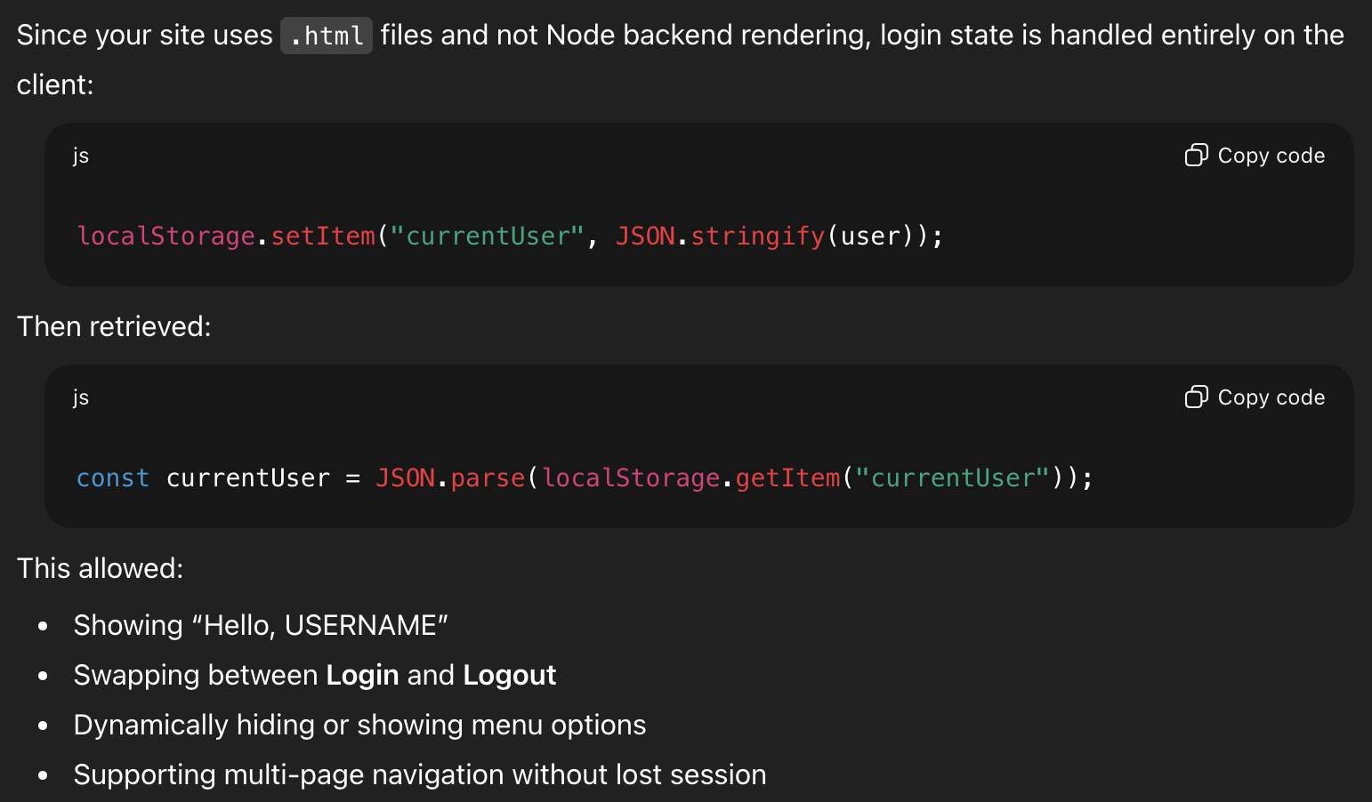

Delete Account Feature
Question: How can You add a “Delete Account” button that appears only when logged in, sends a DELETE request to JSON-server, removes the user’s login session, and redirects to home page?
Summarized Answer:
